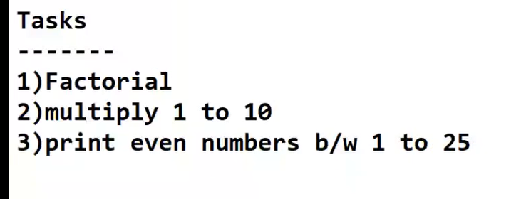

num = int(input("Enter the number: "))  
fact=1  
for i in range (1,num+1):  
 fact=fact\*i  
 #print(fact)  
  
print("Factorial of",num,"is",fact)

Enter the number: 5

Factorial of 5 is 120

total=1  
  
for i in range (1,11):  
 total=total\*i  
 #print("Multiply 1 to 10: ",total)  
  
print("Multiply 1 to 10: ",total)

Multiply 1 to 10: 3628800

for i in range(1,25):  
 if(i%2==0):  
 print(i)

2

4

6

8

10

12

14

16

18

20

22

24